Rossmoyne Senior High School

Examination, Semester 1 2010

Question/Answer Booklet

MATHEMATICS 3C/3D

Section Two:

Calculator-assumed

Student Name

Goh | Robinson | Longley | Birrell | Whyte

Time allowed for this section
Reading time before commencing work: 10 minutes
Working time for this section: 100 minutes

Material required/recommended for this section

To be provided by the supervisor
This Question/Answer Booklet
Formula Sheet (retained from Section One)

To be provided by the candidate
Standard items: pens, pencils, pencil sharpener, eraser, correction fluid, ruler, highlighters

Special items: drawing instruments, templates, notes on two unfolded sheets of A4 paper, and up to three calculators satisfying the conditions set by the Curriculum Council for this course.

Important note to candidates
No other items may be taken into the examination room. It is your responsibility to ensure that you do not have any unauthorised notes or other items of a non-personal nature in the examination room. If you have any unauthorised material with you, hand it to the supervisor before reading any further.

Structure of this paper

Section | Number of questions available | Number of questions to be answered | Working time (minutes) | Marks available
Section One:  Calculator-free | 9 | 9 | 50 | 40
Section Two:  Calculator-assumed | 13 | 13 | 100 | 80
 |  |  |  | 120

Instructions to candidates

1. The rules for the conduct of Western Australian external examinations are detailed in the Year 12 Information Handbook 2010. Sitting this examination implies that you agree to abide by these rules.

2. Write your answers in the spaces provided in this Question/Answer Booklet. Spare pages are included at the end of this booklet. They can be used for planning your responses and/or as additional space if required to continue an answer.
  - Planning: If you use the spare pages for planning, indicate this clearly at the top of the page.
  - Continuing an answer: If you need to use the space to continue an answer, indicate in the original answer space where the answer is continued, i.e. give the page number. Fill in the number of the question(s) that you are continuing to answer at the top of the page.

3. Show all your working clearly. Your working should be in sufficient detail to allow your answers to be checked readily and for marks to be awarded for reasoning. Incorrect answers given without supporting reasoning cannot be allocated any marks. For any question or part question worth more than two marks, valid working or justification is required to receive full marks. If you repeat an answer to any question, ensure that you cancel the answer you do not wish to have marked.

4. It is recommended that you do not use pencil except in diagrams.

Section Two: Calculator-assumed ( 80 Marks)

This section has thirteen (13) questions. Answer all questions. Write your answers in the space provided.

Spare pages are included at the end of this booklet. They can be used for planning your responses and/or as additional space if required to continue an answer.
  - Planning: If you use the spare pages for planning, indicate this clearly at the top of the page.
  - Continuing an answer: If you need to use the space to continue an answer, indicate in the original answer space where the answer is continued, i.e. give the page number. Fill in the number of the question(s) that you are continuing to answer at the top of the page.

Suggested working time for this section is 100 minutes.

- ( 5 marks)
A random variable is normally distributed with a mean  and a standard deviation .
Given that 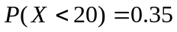 and 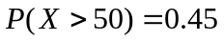, determine:

(a) 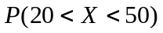
( 1 mark)

(b) the values of and correct to two decimal places
( 4 mark)

- ( 3 marks)
A bacterial culture grows growing according to the rule 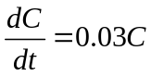, where is the size of the culture and is time measured in days. How long will it take the culture to double in size?
( 3 mark)

- ( 5 marks)
A committee of 6 people is to be chosen to edit the school magazine. 10 girls and 5 boys apply, and the school decides to appoint 4 girls and 2 boys.

(a) How many different committees can be formed?
( 3 marks)

(b) Two of the girls who applied are the twins Sarah and Samantha. Assuming that all possible committees have the same probability of being formed, what is the probability that both Sarah and Samantha are selected?
( 2 marks)

- ( 3 marks)
If 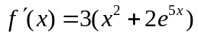 and 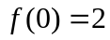
find, as exact expressions:
(a) 
( 2 mark)

(b) 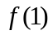
( 1 mark)

- ( 4 marks)
The cost $C for the production of widgets is given by 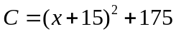
Using calculus, find the value of for which the average cost per widget is a minimum and find this minimum cost.
( 4 mark)

- ( 4 marks)
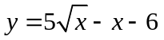
The diagram shows a rectangle ABCD with points A and D having coordinates (4,0) and (9,0) respectively. The shaded region satisfies the inequalities 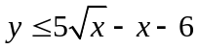 and 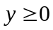.
4
5
6
7
8
9
x
y
A
B
C
D
Find the length AB such that the area of rectangle ABCD is equal to the area of the shaded region.

( 4 marks)

- ( 7 marks)
For independent events A and B, 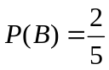 and 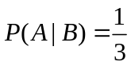, determine :

(a) 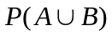
( 3 mark)

(b) 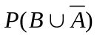
( 2 mark)

(c) 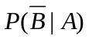
( 2 mark)

- ( 5 marks)
If 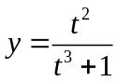, use differentiation to determine the approximate percentage change in if the value of , initially valued at 3, increases by 5%
( 5 mark)

- ( 3 marks)
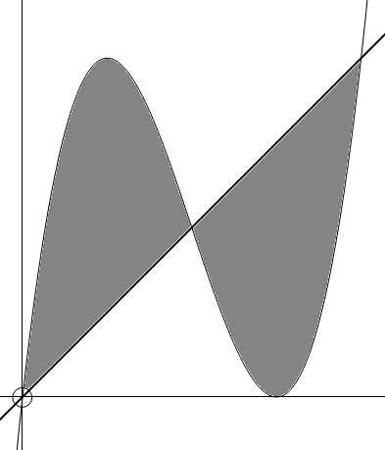
Write an expression involving the use of the definite integral for determining the area trapped by the functions  and 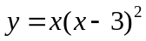 and evaluate it

( 3 marks)

- ( 6 marks)
Three balls are to be drawn one at a time and without replacement from a bag containing four red balls and eight white balls.
(a) Find the probability distribution for the random variable, X, the number of red balls drawn


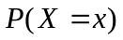
( 2 mark)

. (b) What is the expected number of red balls in this scenario?
( 2 mark)

. (b) Find the probability that two red balls are selected given that at least one of them was red
( 2 mark)
- ( 6 marks)
In a certain large company 15% of the employees have attended a health and safety training course. Of the employees who have attended the training course, 75% are qualified to perform first aid, whereas of the employees who have not attended the training course only 20% are qualified to perform first aid.

(a) What percentage of employees in the company are not qualified to perform first aid?
( 4 marks)

(b) A randomly chosen employee is found to be qualified to perform first aid. What is the probability that he attended the training course?
( 2 marks)

- ( 7 marks)
The Australian Bureau of Statistics reports that the mean weight and standard deviation for Australian males 18 years and over are 82.0 kg and 13.6 kg respectively.
Assuming that the distribution of weights is normal, what is the probability that a randomly selected person in this category:
(a) Has a weight of 90 kg or more?
( 2 mark)

(b) Is within 5 kg of the mean weight?
( 2 mark)

Suppose that an arbitrary definition of being overweight is “has a weight of more than 100 kg”
(c) If three Australian males 18 years and over are randomly selected, what is the probability that at least two of them will be considered “overweight”?
( 3 mark)

- ( 8 marks)
The serving time, seconds, for a customer at an automatic banking machine is a uniformly distributed random variable, with lower and upper limits 50 and 150. The mean serving time is 100 seconds and the standard deviation is 28.9 seconds. The serving times for different customers are independent.
(a) Sketch the graph of the distribution function for .
( 2 mark)
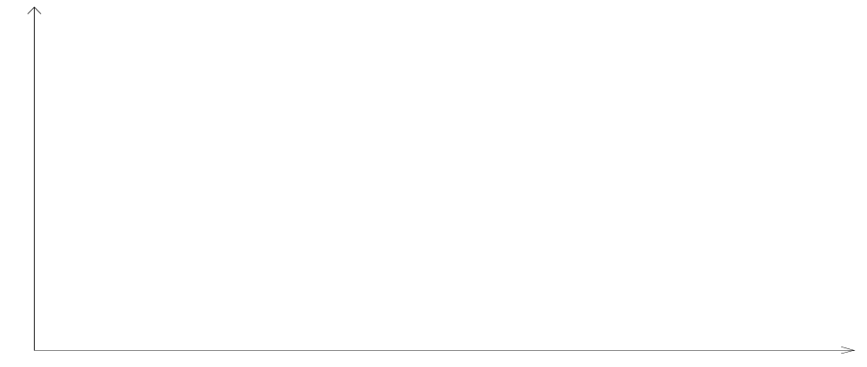
t
(b) Evaluate 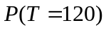
( 1 mark)

(c) Evaluate
( 1 mark)

(d) What is the probability that exactly 3 of the next 5 customers will require at least 2 minutes to be served?
( 2 marks)

(e) What is the probability that fewer than 3 of the next 5 customers will require at least 2 minutes to be served?
( 2 mark)

- ( 6 marks)
Quadrilaterals are to be formed using (as vertices) 2 dots from the top row and 2 dots from the bottom row.
A
B
F
D
C
R
E
T
S
V
U
W
X
Y

(a) How many different quadrilaterals can be formed?
( 2 marks)

(b) How many af these quadrilaterals:
(i) do not have B as a vertex
( 2 marks)

(ii) do not have B as a vertex nor contain B on the upper side
( 2 marks)

- ( 4 marks)
The expected value of a discrete probability distribution is 2.9. The table below shows the discrete probability distribution with missing values and

 | 1 | 2 | 3 | 4 | 5
 | 0.2 | 0.15 |  | 0.25

Determine the values of and
( 4 marks)

- ( 4 marks)
The area of the region bounded by the curve with equation 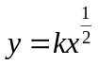, where is a positive constant, the axis and the line with the equation 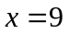 is 27. Find
( 4 marks)

Additional working space
Question number(s):
Additional working space
Question number(s):

